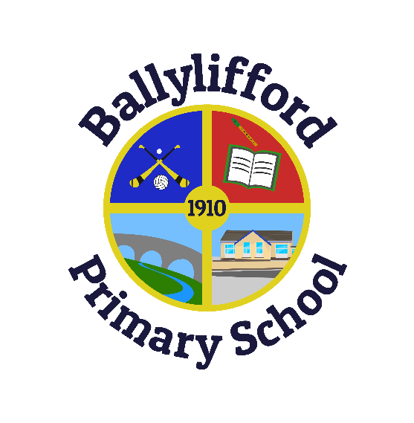
Ballylifford Primary School
142 Ballinderry Bridge Road
Cookstown
Co Tyrone
BT80 0AY

PRINCIPAL: Mr Ciaran McElroy
Tel / Fax: 028 79418388
Email: info@ballylifford.cookstown.ni.sch.uk
Website: www.ballyliffordps.com
Twitter: @BallyliffordPS

Thursday 3rd May 2018

Parents of P4 Pupils
Dear Parents,

First Holy Communion will be celebrated in St. Patricks Church, Ballinderry at 11:00am on Saturday 19th May 2018.

The families and friends of all First Communicants in Ballinderry Parish (Ballylifford Primary School & Derrychrin Primary School) are invited to St. Patrick’s Hall after the Ceremony to enjoy tea, coffee and refreshments provided by both schools and the First Communicants will be provided with a First Communion goodie bag containing lemonade, sweets and crisps. Parents do not have to leave any additional refreshments into the school. Many thanks!

We would be most grateful if we could have a full attendance of the school choir which includes all P3 – P7 pupils. The children involved in the choir will be accompanied by teachers from both schools and they are asked to be at the Chapel for 10:45am and can be collected after the mass at 12noon approx. No school uniform required.

We hope that everyone can join us to celebrate this special occasion. Please indicate below how many family members / friends will be coming back to the St. Patrick’s Hall for refreshments.

There will be no photographer available on the day to take individual photos so we ask families to please make alternative arrangements. Both schools will take joint group photos of all communicants and of both schools.

Yours sincerely,

Mr Ciaran McElroy
Principal
***********************************************************************************************************
*We will / will not be attending the function in St Patricks Parish Centre after First Holy Communion on Saturday 19th May 2018.
There will be ________ people in our party. Signed ____________________________________

