Ballylifford Primary School
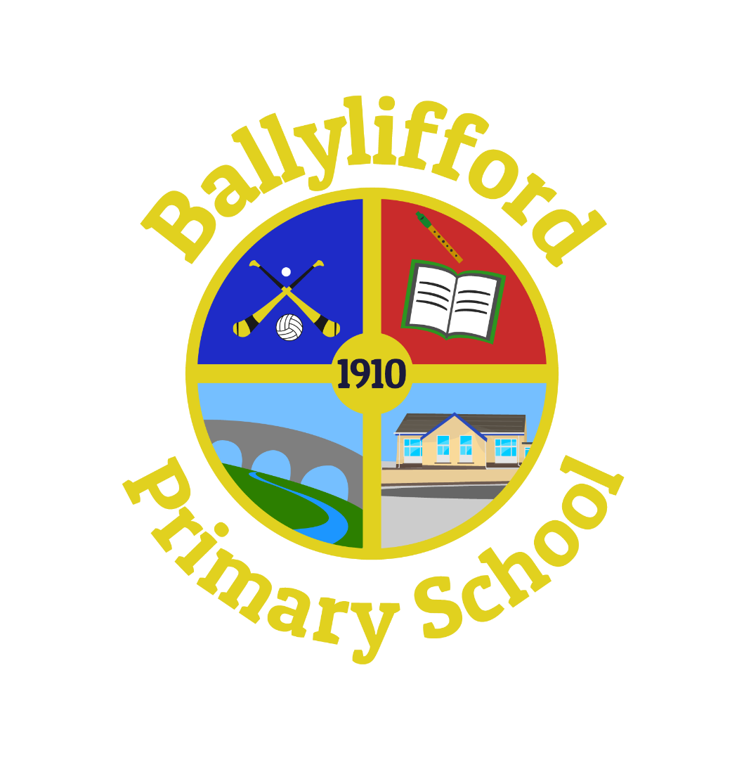

Health Eating & Lifestyle

Policy

INTRODUCTION
We at Ballylifford PS believe schools have an important role to play in encouraging children to make healthy life choices. Educating children on the benefits of healthy eating and regular exercise can bring about both immediate and long term improvements to their quality of life. It is our policy that we promote and encourage healthy lifestyles and therefore healthy eating at break time and lunch time.

A healthy diet is essential for maintaining and protecting children’s health, for ensuring they perform to their full potential during the school day (both academically and physically) and for their growth and development. Our aim is to help them establish a healthy lifestyle that, we hope, will continue into adulthood. A good diet is important for good health. A healthy and varied diet can help maintain a healthy body weight, enhance general well-being and reduce the number of diseases such as heart disease, stroke, cancer, diabetes and osteoporosis. The rise in childhood obesity and illnesses such as the early onset of Type 2 diabetes and heart disease has highlighted the dangers of unhealthy lifestyles.

Proper nutrition is essential for good health and effective learning. The benefits of Healthy Eating include:
- Helps young people develop, grow and do well in school
- Prevents childhood and adolescent health problems such as obesity, eating disorders, tooth decay and anaemia
- May help prevent health problems later in life, including heart disease and cancer
- Establishing healthy eating habits at a young age is critical because changing poor eating patterns in adulthood can be difficult
- Sitting down to a meal with other children is an important part of a child’s social education

Consequences of Unhealthy Eating include:
- Hungry children are more likely to have behavioural, emotional and academic problems at school
- Research suggests that not having breakfast can affect children’s intellectual performance
- Poor eating habits and inactivity are the root cause of overweight and obesity. The percentage of young people who are overweight has almost doubled in the last twenty years
- Eating disorders are extremely common among young people

AIMS AND OBJECTIVES
Ballylifford Primary School recognises the important connection between a healthy diet and a pupil’s ability to learn effectively and achieve high standards in school. The school also recognises the role the school can play, as part of the wider community, to promote family health.

The school aims to:
- Improve the health of children, staff and their families by helping to influence eating habits through increasing knowledge;
- Increase awareness of food issues, including what constitutes a healthy and environmentally sustainable diet; and
- Present consistent, informed messages about healthy eating within school through all school practices.
- Provide a consistent programme of cross-curricular nutrition education that enables pupils to make informed choices without guilt or anxiety.
- Provide a ‘whole school’ approach to nutrition.
- Work in partnership with catering staff to ensure that nutritional standards are implemented by providing attractive, value for money meals that are appropriate for our particular children.
- Work in partnership to achieve a pleasant and sociable dining experience which enhances the social development of each pupil.

At Ballylifford Primary School, healthy eating is delivered within a whole school approach which may include:
Topics;
- Planned aspects of Personal Development and Mutual Understanding (PDMU), the World Around Us, PE and other curriculum areas;
- Special assemblies / visits by agencies.
- Pastoral time (Eg., Circle Time);
- Extra-curricular activities; and
- Special projects.

PUPILS
As part of our ‘Healthy Eating’ policy, pupils are encouraged to:
- eat healthy ‘snack’ at school each day
- eat fruit, vegetables, dairy products or bread based products at lunch time;
- drink water and milk daily at snack and lunch time; as well as water throughout the day;

SCHOOL BREAK
Water should be drunk during the day and fizzy drinks are not allowed to be consumed in school during break times or at any other time of the school day. Fruit drinks etc are only permitted to be taken at lunchtime.

Parents are asked to supply their child with fresh fruit or vegetable portions, natural/fruit yoghurt, pancakes, cracker or a small sandwich/roll with healthy filling for breaktime. Other snacks such as crisps, snack bars, cereal bars will not be allowed to be consumed at breaktime. Special needs and allergies are taken into consideration. Please do not supply any nut based snack or product as Ballylifford PS is a NUT Free School.
It is impossible for staff to check every child’s snack. We rely on our parents to send an appropriate snack following the above guidelines. It is important that the snack sent to school is fresh as many processed or dried snacks contain high amounts of sugar.

SCHOOL MEALS
For many children, the lunchtime meal is the main meal of the day. It is important that meals served are nutritionally balanced. Under-nutrition, even in its milder forms, can have detrimental effects on cognitive development, behaviour, concentration and school performance.

The subtle message that pupils receive about food and health from the daily life of school are as important as those given during lessons, e.g. school menus, peer pressure to eat certain snacks in packed lunches. By working together, we can promote healthier eating habits.
Healthy option weeks, the removal of sauces, the introduction of more fruit as a snack option will improve children’s diet.

The School Meals’ Service promotes healthy eating as the meals provided at lunch time take into account the nutritional guidelines put in place by the Department of Education N.I. and the Education Authority.

As part of our ‘Healthy Eating’ policy the school meals service provide:
- meals that follow the guidelines provided in the publications, ’School Food, Top Marks Nutritional Standards for School Lunches’, ‘Nutritional Standards for other Food and Drinks in Schools’ and ‘School Food, the Essential Guide’.

- milk or water for the children to drink daily;
- fresh fruit and bread with every meal;
- meals that are low in salt content;

Salt is NOT available to be used by the children on their meals.
Special needs and allergies are taken into consideration.

PACKED LUNCHES
Parents and carers are asked to provide well balanced healthy packed lunches for their children. Packed lunches should include some fruit or vegetables e.g. a piece of fruit, dried fruit, cherry tomato, raw carrot, cucumber wedge. Sugary drinks and chocolate snacks should be avoided and fruit juice or diluted squash should be consumed at lunchtimes only. All uneaten food is kept in the lunch box so parents can check on what their children have eaten.

Only water, milk or diluted juice should be provided. Fizzy drinks should NOT be included in the children’s packed lunches.

Only one of the following may be included in lunch boxes;
Sweets (including Winders),
- Chocolate (including biscuits and bars)
- Crisps or any packeted savoury snacks high in salt and fat, eg. Dunkers, lunchables
- Sweet cakes, e.g. sugary cakes, doughnuts
- ‘Fruit Corner style’ yoghurts, eg. Crunch/fruit corner yoghurts, chocolate yoghurts / custard

WATER
Research indicates that school children do not drink enough water during the school day and that this affects their concentration and behaviour.
The school recognises that children concentrate better, are healthier and more comfortable if they are not dehydrated, and the best way of ensuring adequate fluid intake is to provide access to water as needed.
All children are encouraged to bring a bottle of water to school each day. This is kept in an accessible place and children will be allowed access to it throughout the school day and ensure no disruption to their learning occurs.

DIETARY NEEDS
In consultation with parents, a child’s dietary requirements devised by a dietician will be adhered to. If any issues arise, teachers will consult parents or relevant health professionals for advice.

SCHOOL ETHOS, ENVIRONMENT AND ORGANISATION
School meals and packed lunches are eaten in the school hall with tables and chairs being set out by the dinner staff.

The school recognises:
The importance of lunchtime organisation on the behaviour of pupils.
The value of promoting social skills. Teachers, non-teaching staff, canteen staff and lunchtime supervisors work together to create a good dining room ambience and the development of appropriate table manners.

CURRICULUM, TEACHING AND LEARNING
Healthy eating and the exploration of diet and health are covered at both Key Stage 1 and Key Stage 2 in the Curriculum. Through WAU Theme Work and PDMU the children are encouraged to think about diet, health and personal development. This is supported by visits and assemblies lead by staff, visits from external agencies, Healthy School’s Week which will involve Physical Fitness and Healthy Eating, the active encouragement to participate in extra-curricular activities and active health food promotions from canteen staff.

PHYSICAL EXERCISE
Exercise plays an important role in the promotion of a healthy lifestyle. It not only brings physical benefits but psychological ones too. Research has shown that it can help combat depression and raise self-esteem. All children are encouraged to actively participate in Physical Education and swimming lessons. A variety of extra-curricular activities including a variety of sports are available for children to join.

P1-P7 pupils now participate in the Daily Mile initiative, whereby children from each class walk, jog or run with their classmates in the safety of the playground. This helps children improve their physical, emotional and social health and well-being by doing at least 15 minutes of physical activity each day.

DRINKS

SUITABLE: | Water: tap water /unflavoured, still, bottled water. | Milk: all whole, semi-skimmed or skimmed unflavoured milk.
NOT SUITABLE: | fruit juices (including pure fruit juice), smoothies, sparkling water, squash or fizzy drinks, even those labelled ‘no added sugar’, ‘diet’ or ‘zero’.

SNACKS
Help your child get their five a day by including some fruit or vegetables as a snack for their morning break. This includes all fresh fruit and vegetables and pots or tins of fruit in fruit juice, but NOT in syrup.

A portion could be:
1 medium sized piece of fruit, | eg apple, orange, banana, pear
2 small fruits, | eg kiwi fruits, satsumas, plums
1 cup of grapes, cherries or berries
1 large slice of pineapple or melon
1 cereal bowl of salad, | eg lettuce, tomatoes, cucumber and celery
3 heaped tablespoons of fresh veg, | eg chopped or sliced carrots, peppers or sugar-snap peas
3 heaped tablespoons of fruit salad | (fresh or tinned in fruit juice)

- For younger children (4–6 years), reduce these portion sizes by about half, then increase the amount as they grow.

- Older primary school children should be eating full portions.
NOT SUITABLE:
fruit tinned in syrup, dried fruit (eg raisins, sultanas) and processed fruit bars (eg fruit winders, fruit flakes etc). These are high in sugar and can cause tooth decay, so are not suitable as between-meal snacks.
Children need more or less energy (calories) depending on their age and stage of development. Bread-based snacks can help to meet these extra energy needs and help your child feel more satisfied. This includes white or wholemeal bread, rolls or baguettes, toast, plain bagels, wheaten, soda, potato or pitta bread, spread thinly with a little margarine, low-fat spread or butter; plain bread sticks or crackers, a small sandwich with a sugar-free filling such as tomato, tuna, chicken, cheese etc.
NOT SUITABLE
Sugary spreads, including jam, honey, marmalade or chocolate spread as these are harmful to teeth. Peanut butter is high in fat and salt so is not recommended.
AVOID:
Cereal bars, or sweetened breads and pastries, eg pancakes, scones (plain and fruit), fruit bread, malt loaf, brioche, croissants and Danish pastries as these contain a lot of sugar and/or fat and salt.

Signed: _____________________________BoG Chairperson

Signed: ___________________________________Principal

Approved by Governors: February 2022 Next Review: February 2025

