Ballylifford Primary School
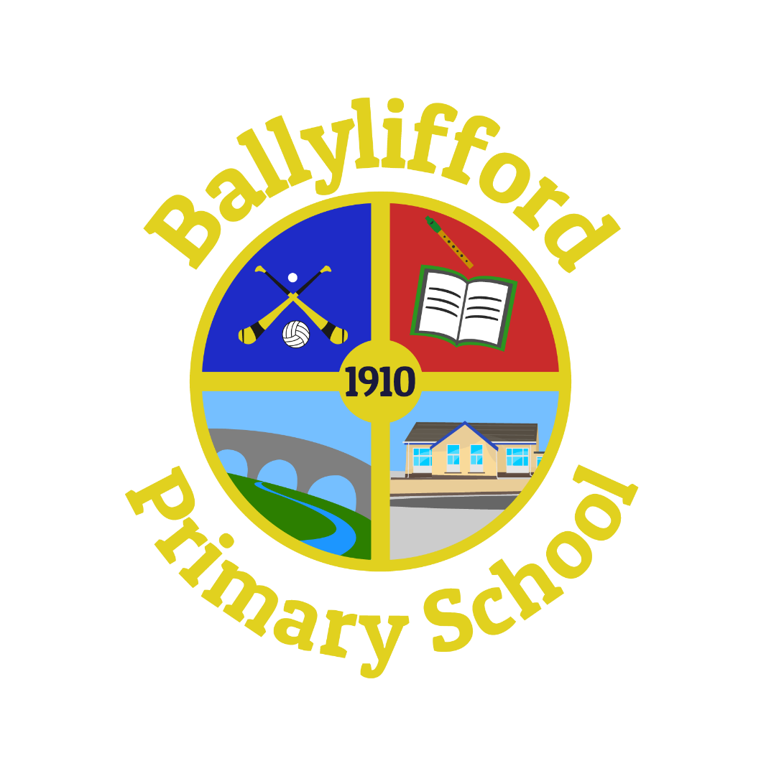

Health and Well Being Policy

Ballylifford PS is committed to working in partnership with parents, all staff, Governors and wider community agencies, to develop the health and well-being of all our pupils.
Introduction
It has been recognised that promoting healthy life styles assists in the process of raising levels of pupil achievement and promotes positive behaviour. Childrens’ health and well-being is more important now than ever due to the current Covid Pandemic. Children have experienced a number of school closures and have had to participate in Remote learning. They have missed out on lots of practical learning opportunities, group work and development of their social skills. Health and Well-being of staff and Pupils will be a primary focus for this school year.

Aims of Health & Well-being in Ballylifford PS
• To promote the physical, social, mental and emotional health and well-being of all pupils.
• To work with outside agencies in meeting the health and well-being needs of the whole school.
• To engage parents and guardians in our endeavours to promote health and well-being.
• To encourage healthy eating habits among the children in our school.
- To develop confidence and self-esteem as children return to school.
- To develop social skills with peers and adults.

This policy has links with other Pastoral Policies:
• Positive Behaviour Policy
• Health & Safety Policy
• Online-Safety Policy
• Acceptable Use of Internet Policy
• Educational Trips Policy
• Administering of Medication Policy

School Ethos
We work together as a team at Ballylifford PS to create a happy, positive, secure and inclusive environment for every member of the school community.

We have a child centred approach and are dedicated in ensuring that every activity has our children’s needs and interests as the first priority. We strive to develop the whole child – academically, emotionally, physically, spiritually and socially.

We promote a Christian and caring ethos and aim to develop a culture of respect, fairness, cooperation, perseverance, self-discipline, forgiveness, honesty, kindness, acceptance and responsibility at all levels within the school. Our ethos is reflected in all areas of school life.

We aim to promote relationships built on honesty, trust, respect and openness, ensuring everyone is valued and respected and feel a sense of belonging to our school where the efforts and achievements of all are celebrated.

We believe that happy children, staff and parents are key to positive learning experiences and a successful school. We believe our ethos and values underpin the well-being of each member of our school community. Celebrating our children’s efforts and achievements in many forms in school with our school family and parents and on a wider scale in local/social media, develops within our children a sense of success and develops their self-esteem and confidence thus encouraging a positive sense of well-being.

Staff are committed to continuous personal self-development, improvement and providing a broad and balanced curriculum in a stimulating setting. Through effective, high quality teaching and learning, our goal is to develop independent, motivated and lifelong learners.

Children are supported and challenged accordingly as they are encouraged to reach their full potential. We seek high standards of achievement and behaviour as we inspire every member of the school community to be the best they can be in all areas and succeed in fulfilling their own personal goals.
We believe high standards and high expectations create within our children an innate sense of self-worth as they are encouraged to do their best and undertake activities matched to their interests and ability.

We are dedicated to providing opportunities for everyone to have a voice and listen respectfully to the views of others. We carry out surveys with our children and through regular circle times listen to the opinions of others. Our children also have a say through Eco-council and our School Council, who make valuable contributions to decisions effecting school life.

We recognise and appreciate the important role parents play in their children’s education and we encourage them to be involved in the life of our school. We also value our parents’ input and feedback on school matters through regular questionnaires. We enjoy parental support at many events throughout the year whether social events or events aimed at sharing information with our parents. We appreciate parent volunteers assisting on school trips and also in our after school clubs.

We are proud of our local community and aim to be a school that has Ballylifford and its people at the core. It is our vision to see our school grow in the community as we provide increasing opportunities for our children to participate, contribute, value and take pride in their local village as they do their school. We enjoy many community events throughout the year, such as the celebration of the Sacraments of Confirmation and First Communion, links with Ballylifford Primary School and taking part in numerous events organised by Mid-Ulster Council.

The School Curriculum
In Ballylifford Primary School the children are taught about healthy living in order to equip them with the skills, knowledge and understanding that will enable them to live positive, successful and healthy lives.

Throughout the various year groups, children receive visits from a dentist and nurse in order to promote good oral hygiene and good health, bake bread as part of their WAU learning or carryout various strands of ‘Keeping Healthy’ in PDMU lessons using the Living Learning Together resources and activities.

The children are also kept aware of health and well-being issues through regular assemblies on the topic of health and well-being. We have displays throughout the school which celebrates children’s work and achievements as well as portray important messages on health and well-being. The school nurse visits P7 class to discuss puberty and change.

Healthy Breaks
In Ballylifford Primary School healthy breaks are promoted. The children are encouraged to eat a portion of fruit along with milk or water. Alternatively, they can eat toast which is made by the pupils for the pupils in each classroom. The children are encouraged to take water into class to drink throughout the day to stay hydrated.

School Meals
The importance of health education in the curriculum is reinforced by the canteen staff, who serve highly nutritious meals. Free milk/ water is provided with school dinners. The School Council will get the opportunity to meet with the lunchtime supervisors and the kitchen staff to help encourage children to adopt healthy lifestyles. All kitchen / school staff value positive relationships with the children and there is a positive and happy atmosphere amongst pupils and staff during lunchtime.

Children can also bring a healthy packed lunch to school. They are also encouraged to eat a piece of fruit at lunchtime. Parents are regularly updated on health initiatives through the school newsletter.

Educational Outings
Ballylifford Primary School takes children on school outings outside of the classroom that will stimulate learning and promote enjoyment. We aim to have termly educational trips related to WAU topics for each year group as well as fun trips at Christmas and end of year. Outings into our local surroundings are also promoted as well, such as litter picks, car surveys, bird watching and projects in liaison with Derrychrin Primary School and Mid-Ulster Council. These trips help children develop in independence, socially, physically and emotionally.
A risk assessment is carried out prior to all trips and parental consent is sought annually. Parents are provided with details on all such trips. (Please refer to Educational Trips Policy).

Safety of children
The school is equipped with a security door at the front entrance to our school. Security locks are on during the school day and anyone wishing to gain entry to the school must press the buzzer. Visual posters remind visitors to report to the school office. Only a member of staff will permit entry to the building, children are not allowed to open the doors. Visitors to the school sign in and wear a school visitor badge. Visitors, such as maintenance workers etc. are supervised at all time while on premises. Parents wait in the school foyer if picking up a child early or delivering messages. A Summary of Safeguarding Procedures are displayed for all visitors and a full copy of procedures and policy given to regular visitors to the school.
All pupils in main building are dismissed through the back doors of the school onto the playground, where they will be collected by the parents / guardians. Parents inform school if there is any change in person picking a child up or if arrangements change.
Road Safety
Road Safety is an important part in the school curriculum. Children throughout the school have the opportunity to go on a walks in their local area to learn about hazards on the road and how to cross the road safely. School staff keep up-to-date with and implement new initiatives in teaching road safety using the calendars provided by Road Safety and additional documents provided by EA/Safety NI throughout the year. Whole school Road Safety assemblies are held every half term. The school takes part in ‘Road Safety Week’ on an annual basis with poster competitions and literature home for parents.

Bee Safe
The P5-P7 pupils have the opportunity to take part in the Council ‘Bee Safe Programme’. Bee Safe is an imaginative way of teaching the pupils to prevent everyday accidents and dangerous situations and how to deal with them safely if they occur. Organisations such as PSNI, Women’s Aid, Transport NI, take part in the event, providing workshops and leaflets for the children.

Break & Lunchtime Routines
During break and dinner all children must go outdoors - weather permitting. All pupils are continuously encouraged to wear their coat outdoors in inclement weather. Children are permitted to stay indoors only if written consent has been given by parents.

Medication
If a child requires medication during the school day, parents should inform the class teacher and complete Medical Administration forms obtained from the school office. Parents can visit during break or lunch time to administer medication. Parents are issued with medical information forms which are updated annually.

Internet Safety
We regularly use the Internet in school. In order to minimise the risk of children coming across unsuitable material, we provide constant supervision, and we use only a filtered service, selected links, and child- friendly search engines. Parents are asked to sign authorisation for their child to use the Internet. We also seek parental permission before using photographs of children or their work on the school’s website, or in newsletters and other publications. (Please refer to Online Safety Policy and Acceptable Use of Internet Policy.)

Walk to School Week/ International Walk to School Month
With support from SUSTRANS NI we hope to participate in October is International Walk to School Month. During this month the pupils will make a special effort to walk to school. The children also have the opportunity to take part in Walk to School Week every year in May.
We also encourage all children to participate in the Daily mile.

Cycling Proficiency
With support from SUSTRANS NI the P5-P7 children have the opportunity to take part in the Cycling Proficiency organised by staff. This programme introduces the children to the Highway Code for young road users. It teaches them about the importance of hazard awareness and the importance of wearing protective headgear when cycling.

Outdoor Play
All children throughout the school have the opportunity to use the school’s several outdoor play areas. Outdoor play has many benefits for children’s health and well-being. Children have the opportunity to develop motor skills and co-ordination. It also helps develop a life-long good habit of daily exercise. The benefits of exercise and outdoor play are continuously addressed in our whole school assemblies.
We are currently working on the development of our Outdoor Play area and implementing it into the curriculum. Outdoor Learning experiences are now extremely important due to the Covid Pandemic.

Extra-Curricular Activities:
The wellbeing of pupils is also promoted through after school activities including Gaelic football and Camogie. Throughout the year the school participates in fixtures against other local schools. This introduces a competitive element to team games and allows children to put into practice the skills they have developed in their lessons. These opportunities foster a sense of team spirit and cooperation amongst the children.
Afterschool clubs such as Drama, Gymnastics, Dance, Arts & Crafts, Golf, Multi-Skills provide opportunities for all to participate.

Outside Agencies
The Fire Service visit the school on a number of occasions e.g. coming up to Halloween to teach the children about the importance of being safe around fireworks. The children have the opportunity to watch video clips, presentations and to ask questions to their local fire safety officers. The Fire Service visit again to further educate Key Stage 2 children on other fire safety risks within the home.

The PSNI visit our school assembly to carry out ‘Stranger Danger’ talk and attend an information evening for parents to advise parents on Internet Safety.
Other visitors to school include the school nurse providing puberty talk and farmer to inform children on farm hazards and taking necessary precautions.

Ballylifford PS places highest importance of Health and Well-Being in school and at home and we will strive at all times to keep abreast of new initiatives and implement them where valuable to the pupils.

Health and Well-being activities
- Grow and Grow + programme delivered by Fresh Little Minds
- Soft Programme for mental health and well-being
- Calm Kids – mindfulness and yoga
- Active Kids – weekly PE sessions
- ‘Feel Good day’ at the end of every month for all staff and children

Signed: _____________________________BoG Chairperson

Signed: ___________________________________Principal

Approved by Governors: February 2022
Next Review: February 2025

